**Test Document**

**Project** : Flutter_Comments_Application

Document History :

|  |  |  |  |
| --- | --- | --- | --- |
| **Version** | **Date** | **Author** | **Comments/Change Description** |
| 1.0 | 10.09.2025 | Kavya Chokkalingam | Initial Testing Documention |

**Requirement :**

To create a flutter app to post a comment and to check the existing comments

**Technology and Tools :**

**Frontend** : Flutter, Dart

**Backend** : Python with FastAPI

**Database** : SQLite

**Version Control** : Git, GitHub

**IDE / Editor** : VS Code

**Others** : Virtual environment (venv), Flutter DevTools

**Test Cases**

**Test Case 1 :**

1. Check the flutter comments app in a web browser

Flutter app being opened in chrome. We can see that while click and dragging anywhere over the existing paragraph a small pop-up named “**Add Comment**” is visible to the top left corner.

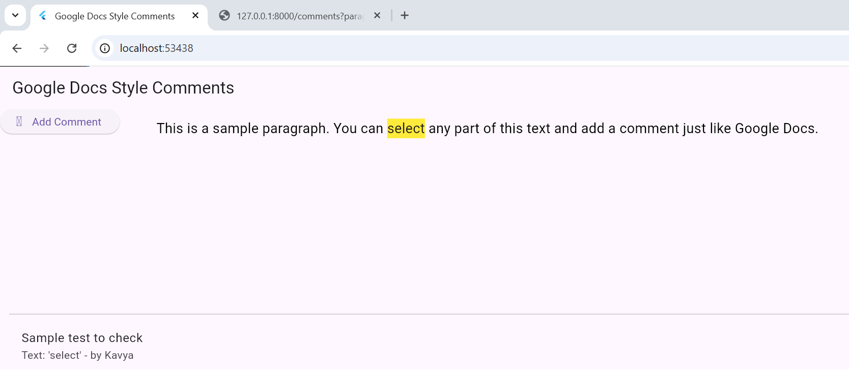

1. Adding a comment to check.

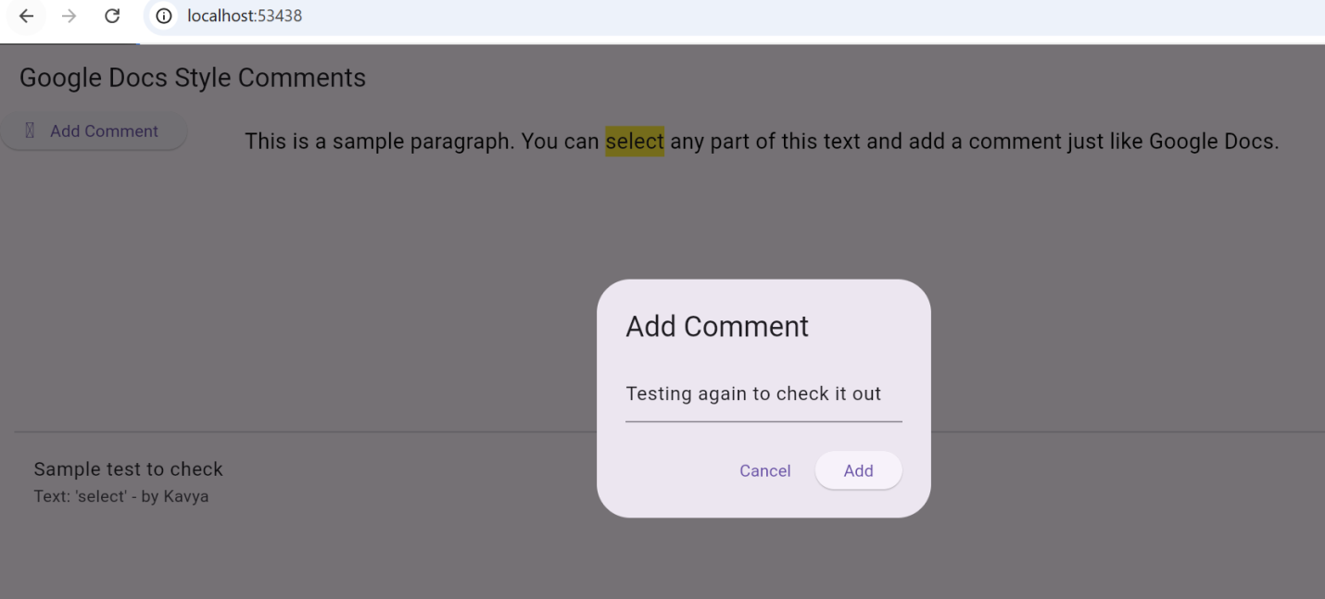

1. Here we can see all the saved comments as JSON (JavaScript Object Notation) 